Operator Button Mapping (Mar 3, 2018)

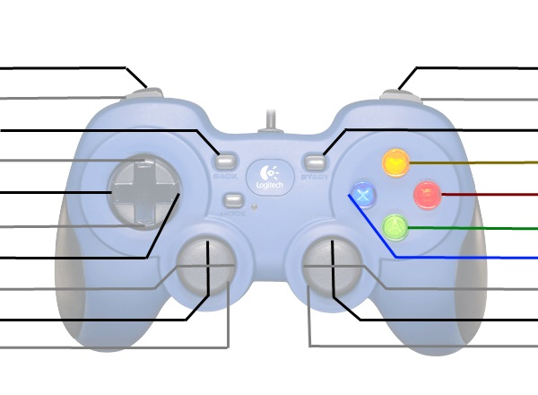

Switch Height

Low Scale

Elevator Down Full

Intake In/Out

Kill Everything

Middle Scale

High Scale

Arms Down

Drop Box

Intake

Ground Intake

Arms Up

Elevator Up/Down

Kill Everything

Driver Button Mapping (Mar 3, 2018)



Arcade Fwd/Back

Kill Everything

Shift Gears

Set Climb Bar

Jaw Climb Pos.

Arcade Turn

Kill Everything